

**Analysis Using a Smart**

**Supply Chain from DataCo**

**Supply Chain Analytics**

(MGT3015)

SLOT:- F1

**Team Members**

20MIA1016-DARSI VENKATA SAI MAHIDHAR

20MIA1019-KANAPARTHI ROSHIN SAI

20MIA1031-SANJAY.M

20MIA1039-SRIGANTH R

20MIA1117-PILLARAM MANOJ

**ABSTRACT:**

The modern landscape of supply chain management has witnessed a profound transformation through the integration of Big Data Analysis into DataCo's SMART System. This advanced system harnesses a diverse dataset, including order details, inventory levels, production schedules, transportation data, weather conditions, market trends, and customer feedback. Through real-time analytics, artificial intelligence, and big data, the SMART System optimizes supply chain operations. This report delves into the architecture, techniques, and capabilities of the SMART System, with a specific focus on the application of machine learning, artificial intelligence, predictive analytics, and prescriptive analytics models. It also highlights the plan to leverage data visualizations using Tableau software. The core problem addressed is the imperative need for supply chain companies to monitor customer delivery performance to enhance customer satisfaction, boost productivity, and maintain market competitiveness.

**PROBLEM STATEMENT:**

Supply chain company must prioritize monitoring customer delivery performance in order to improve customer satisfaction, optimize productivity, and maintain competitiveness in the market.

**INTRODUCTION:**

Supply chain management plays a pivotal role in the success and competitiveness of businesses across various sectors in today's interconnected global corporate environment. The intricacies of managing a network of suppliers, manufacturers, distributors, and retailers necessitate precision, efficiency, and adaptability. The fusion of big data analytics with supply chain management has ushered in an era of data-driven decision-making in this dynamic landscape. The SMART System, with its intricate dataset, advanced architecture, and sophisticated approaches, lies at the heart of this revolution. It offers a comprehensive understanding of how raw data is processed into valuable insights, empowering organizations not only to respond swiftly to market changes but also to anticipate and manage supply chain challenges.

However, the adoption of the SMART System in a supply chain setting comes with its set of considerations. Businesses must carefully weigh the benefits against potential drawbacks associated with implementing cutting-edge technologies. While the system promises substantial advantages in terms of efficiency, cost savings, and improved decision-making, it presents challenges related to data security, integration, and the need for specialized personnel. Striking a balance between these benefits and potential drawbacks is essential to remain competitive in a constantly evolving market

**LITERATURE REVIEW:**

The DataCo SMART (Supply Chain Management Analytics for Real-Time) system represents a cutting-edge approach to harnessing the power of big data analytics for optimizing supply chain operations. It relies on a diverse and constantly updated dataset, encompassing order details, inventory levels, production schedules, transportation data, weather conditions, market trends, and customer feedback. At its core, the SMART system employs a deep neural network-based machine learning model, combining recurrent and convolutional neural networks for tasks like time-series forecasting, anomaly detection, demand prediction, and route optimization. It offers real-time insights, improving efficiency, customer satisfaction, and adaptability, all driven by data. However, it comes with challenges, such as data integration complexities, high computational requirements, ongoing model maintenance, data privacy concerns, and initial implementation costs. Future research should focus on scalability, explainability, sustainability, integration with emerging technologies, and benchmarking for broader industry applications.

This paper offers a comprehensive overview of predictive big data analytics techniques applied to supply chain demand forecasting, emphasizing the critical role of accurate forecasting in optimizing inventory management and enhancing customer satisfaction. The discussion covers diverse data sources for demand forecasting, modeling approaches, and key phases in the forecasting process. Various methods, including traditional time series analysis, machine learning, deep learning, Bayesian methods, and ensemble techniques, are explored for demand prediction. The pros of these techniques encompass enhanced accuracy, cost reduction, improved customer satisfaction, adaptability, and data-driven decision-making. On the downside, challenges include data quality, computational resource requirements, model complexity, implementation costs, and ongoing model maintenance.The paper also highlights significant research gaps in this field, which include uncertainty management, real-time analytics for dynamic environments, scalability for large-scale supply chains, integration with IoT data, sustainability considerations, and ethical issues related to data privacy and transparency. Addressing these research gaps is crucial for advancing the domain of predictive big data analytics for supply chain demand forecasting and meeting the evolving demands of modern supply chain management.

This research paper presents an in-depth exploration of predictive big data analytics techniques applied to supply chain demand forecasting, emphasizing the pivotal role of accurate forecasting in optimizing inventory management and enhancing customer satisfaction. The dataset used for demand forecasting comprises historical sales data, market trends, weather conditions, economic indicators, and customer behavior data, characterized by its significant size, heterogeneity, and frequent updates, rendering it suitable for big data analytics applications. The paper covers various modeling approaches, encompassing time series analysis, machine learning, deep learning, Bayesian methods, and ensemble techniques, tailored to accurately predict future demand.In the pros section, the paper highlights enhanced demand forecasting accuracy, cost reduction through optimized inventory management, improved customer satisfaction by ensuring product availability, adaptability to changing market dynamics, and informed decision-making based on data-driven insights. Conversely, in the cons section, challenges include potential inaccuracies due to poor data quality, computational resource requirements for advanced models, complexity and interpretability issues in certain models, initial implementation costs, and the ongoing need for model maintenance and updates.The research paper also identifies critical research opportunities in this field, including developing methods to quantify and manage uncertainty in forecasts, real-time analytics to address rapidly changing supply chain environments, scalable solutions for large-scale supply chain networks, the integration of IoT data to enhance forecasting, investigating sustainability aspects of predictive analytics, and addressing ethical issues related to data privacy and transparency in supply chain analytics. These research areas are pivotal for advancing the realm of predictive big data analytics for supply chain demand forecasting.

Real-time prediction models in supply chain management encompass essential stages like data preprocessing, feature engineering, model training, validation, and prediction. These models are designed to deliver real-time forecasts and insights, ultimately optimizing supply chain operations.The benefits of such models include improved demand forecasting accuracy, heightened responsiveness to market changes and disruptions, cost reduction through optimized inventory and transportation operations, increased customer satisfaction, and data-driven decision-making. However, challenges like data quality issues, computational resource requirements, model complexity, initial implementation costs, and the need for ongoing model maintenance must be considered.Furthermore, critical research gaps in the domain of real-time prediction models for supply chain management include developing methods to manage uncertainty in real-time predictions, investigating scalability for large-scale supply chain networks, exploring the integration of IoT data for enhanced real-time predictions, addressing ethical concerns related to data privacy and transparency, and establishing standardized benchmarks for assessing the effectiveness of real-time prediction models across diverse industries and domains. These research areas are essential for advancing the field of real-time prediction in supply chain management.

This systematic literature review delves into the role of Big Data Analytics (BDA) in Supply Chain Management (SCM). It synthesizes a substantial body of literature spanning several years, shedding light on key findings and outlining future research directions in this domain. The analysis explores the wide array of data sources used in BDA for SCM, the various models and approaches employed, as well as the advantages and disadvantages of integrating BDA into SCM.BDA in Supply Chain Management leverages a diverse set of datasets from sources like order data, inventory levels, transportation data, weather conditions, market trends, and customer feedback. These datasets are often characterized by their size, unstructured nature, and dynamism, necessitating advanced data preprocessing and purification techniques. To manage and analyze this vast data, BDA deploys technologies and methods such as data warehousing, data lakes, and cloud-based platforms.The models utilized in BDA for SCM are multifaceted and tailored to specific SCM objectives.

These include Predictive Analytics, Prescriptive Analytics, Machine Learning, and Artificial Intelligence models. Predictive models estimate demand and anticipate market trends, while prescriptive models recommend optimal actions. Machine Learning and AI models automate processes and enhance decision-making through pattern recognition and anomaly detection.Pros of integrating BDA in SCM encompass enhanced decision-making, streamlined processes, improved demand forecasting, early disruption identification, and a competitive edge through data-driven strategies. However, challenges include the management of large and diverse datasets, data security concerns, the need for specialized skills, infrastructure costs, and the complexity of integrating BDA systems with existing SCM setups.In the systematic literature review, a significant research gap is identified, primarily related to the limited focus on practical implementation and real-world case studies. While there is extensive discussion about the theoretical potential of BDA in SCM, empirical studies and practical insights illustrating successful BDA implementation in various supply chain contexts are notably lacking. Bridging this gap with comprehensive case studies is crucial to provide organizations considering BDA adoption in their supply chain processes with valuable insights and real-world examples.

**DATASET DESCRIPTION:**

The SMART system relies on a diverse dataset collected from various sources within the supply chain. This dataset includes information such as order details, inventory levels, production schedules, transportation data, weather conditions, market trends, and customer feedback. The dataset is extensive and is updated in real-time, allowing for the most up-to-date analysis of supply chain operations.

**Order Details:** Data about client orders, purchase orders, and sales transactions are included in this section of the collection. It reveals information on demand trends, order quantities, order frequency, and order lead times. This data analysis aids in the optimization of inventory levels, production scheduling, and order fulfillment operations.

**Inventory Levels:** Inventory management requires information on inventory levels across several locations and product categories. It identifies overstocked and understocked products, assisting firms in maintaining efficient stock levels while lowering carrying costs.

**Production Schedules:** Production schedule data gives insight into manufacturing processes such as production rates, lead times, and capacity utilization. It aids in ensuring that output matches demand, lowering the danger of stockouts or surplus inventory.

**Transportation Data:** This category contains information on the movement of commodities across the supply chain. shipment routes, travel periods, carrier performance, and shipment prices are all covered. Transportation data optimization may improve logistics efficiency and lower shipping costs.

**Weather Conditions:** Weather data is useful for determining the influence of weather on supply chain activities. It assists firms in preparing for weather-related disruptions such as hurricanes, snowstorms, or severe temperatures, which can have an impact on transportation, warehouse operations, and demand patterns.

**Market Trends:** Understanding market trends and industry dynamics allows businesses to react to changing market conditions. This data contains competitive insights, price patterns, and customer preferences, which may be used to make strategic decisions.

**Customer Feedback**: Customer feedback and sentiment analysis give significant insights into customer satisfaction, product quality, and brand reputation. This information assists businesses in improving their goods and services as well as building stronger client connections.

**dataorders**: This column likely contains information related to order data, such as order dates or order numbers.

**categoryname:** This column appears to pertain to the category of products or items being sold, which can help classify and organize sales data.

**market**: This column could represent the specific market or segment where the sales are taking place, providing insights into the sales environment.

**departmentname**: This column might refer to the department or section within the business responsible for these sales, indicating the source or origin of the orders.

**latitude and longitude**: These columns could potentially contain geographical coordinates, which might be relevant for analyzing sales and distribution locations.

**sales,stat**e: This column possibly contains information about the state or location where the sales transactions occurred.

**price, sales, and quantity:** These columns likely store details about the price of the products sold, the total sales amounts, and the quantities of items sold in each transaction.

**orderstatus**: This column could contain the status of each order, such as "pending," "shipped," or "completed."

**Results and Discussion:**

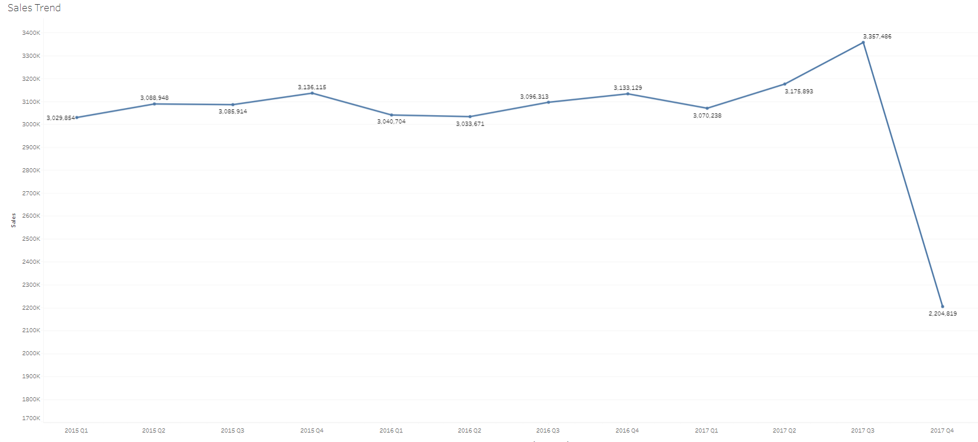

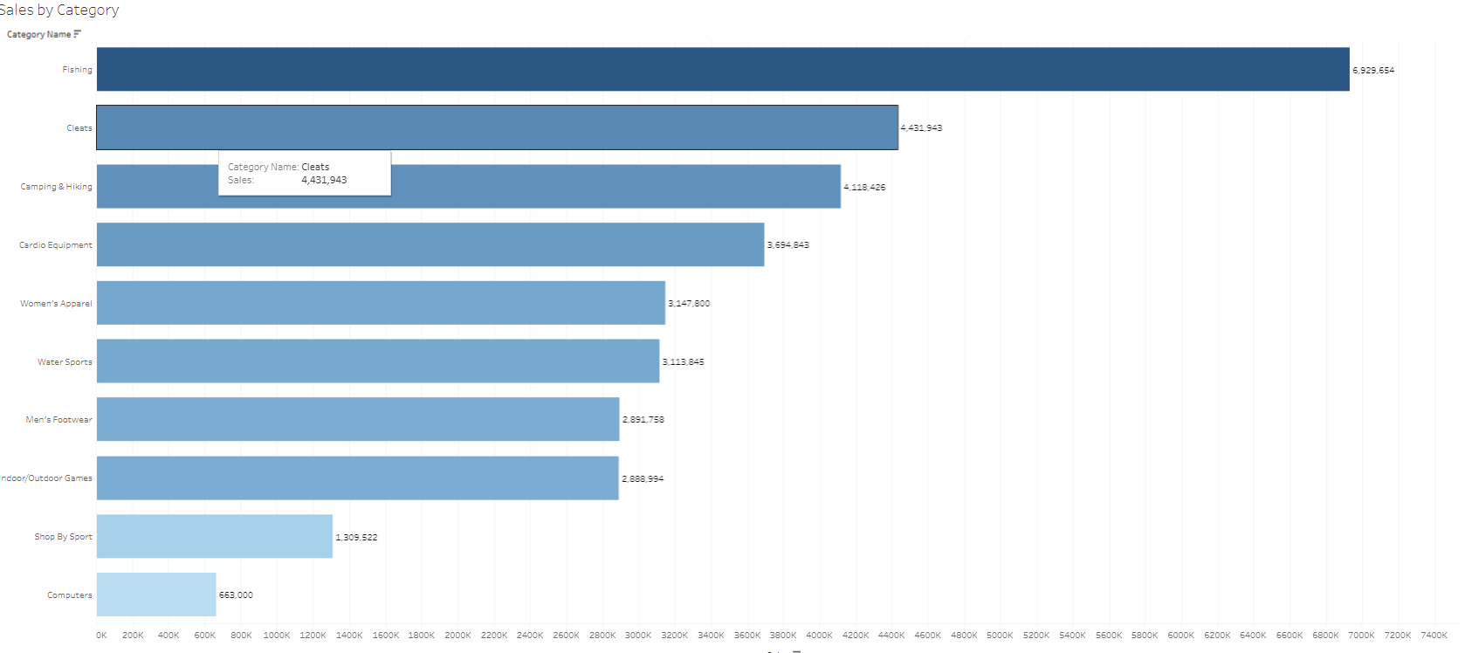

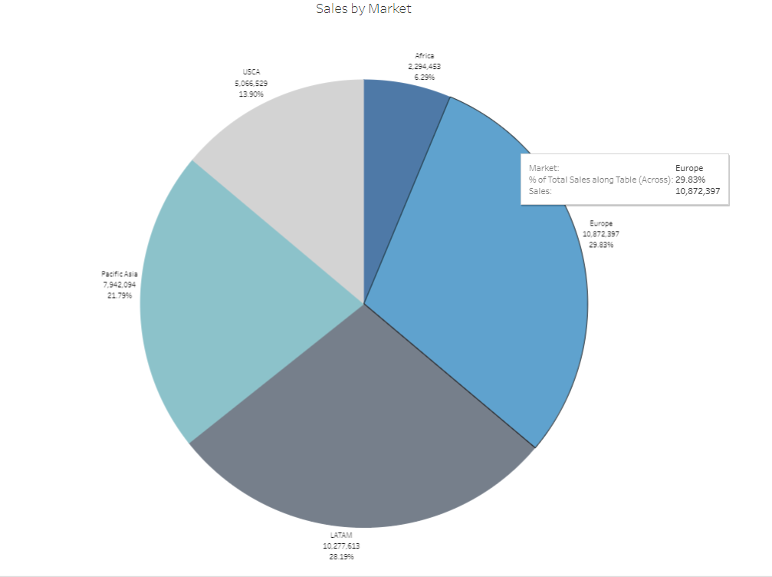

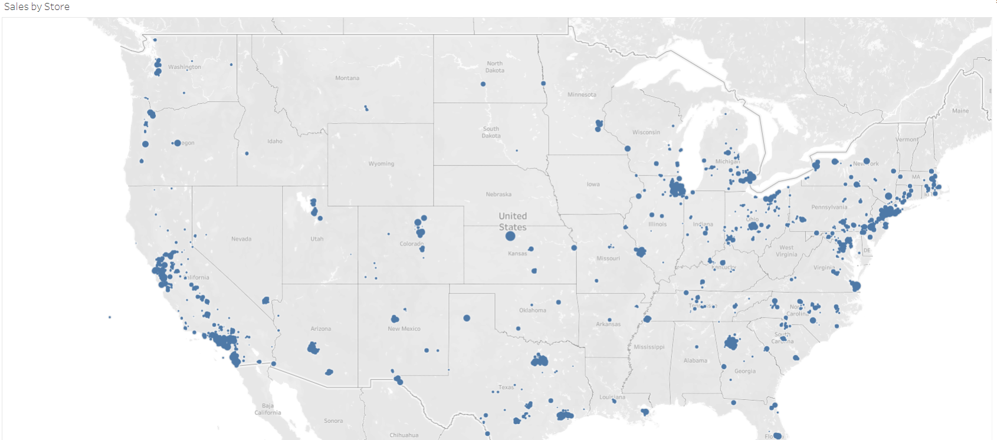

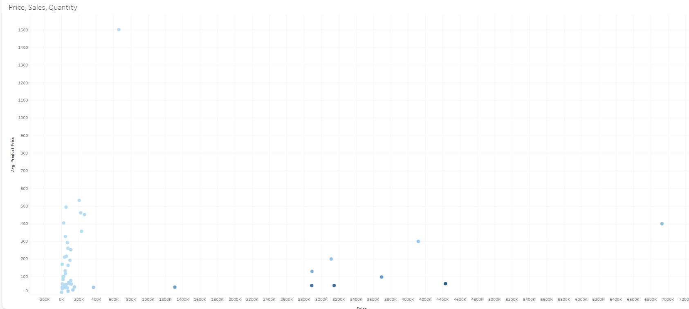

\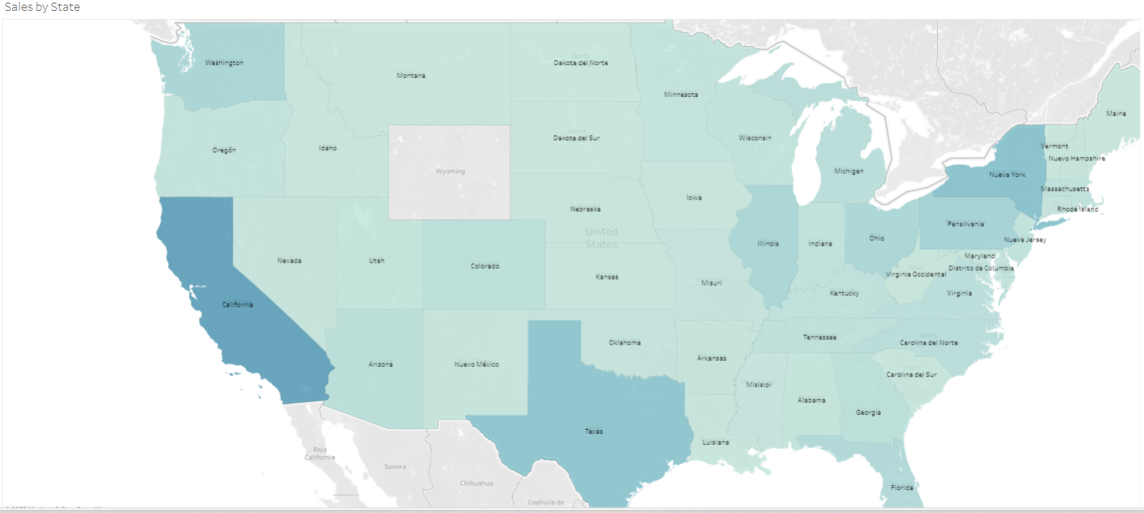

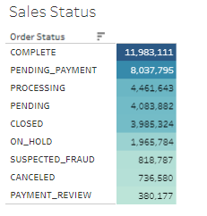

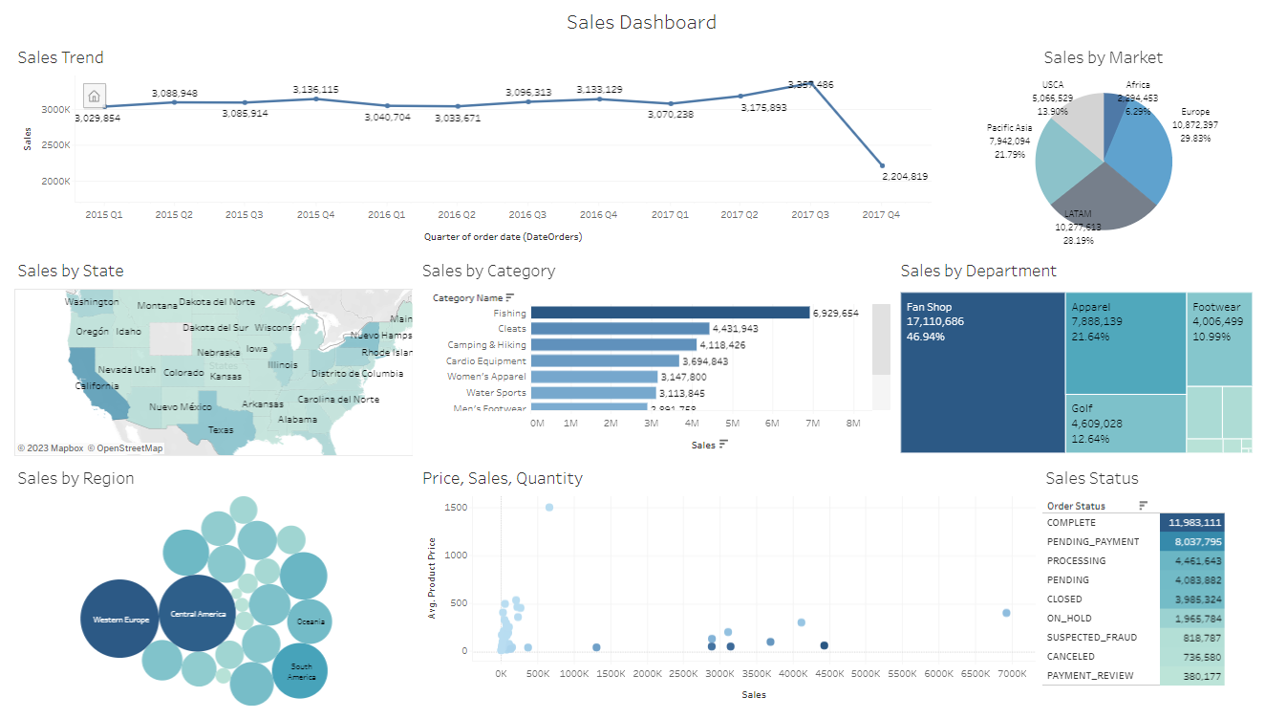

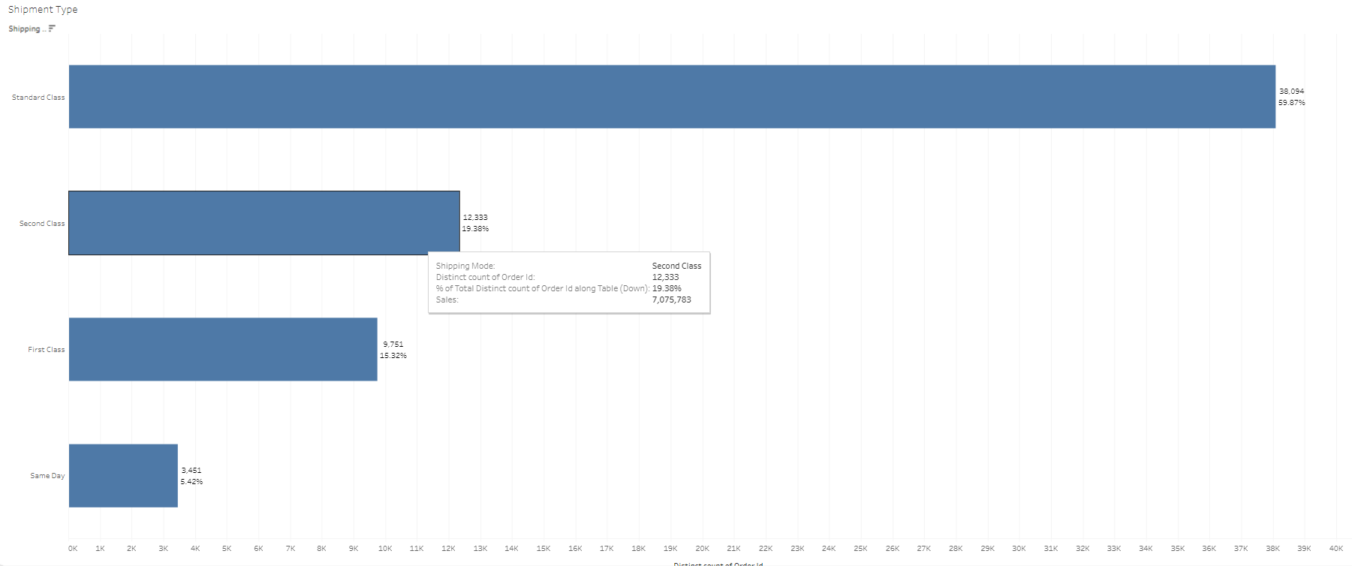

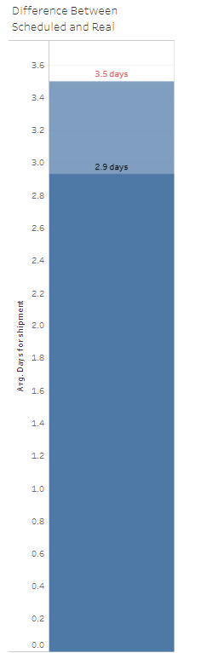

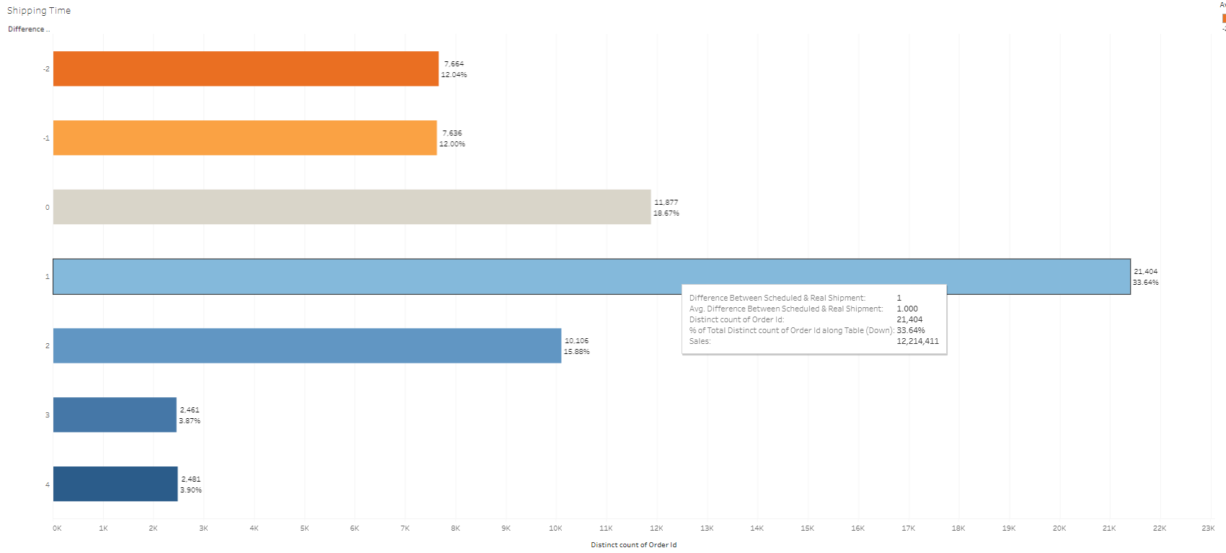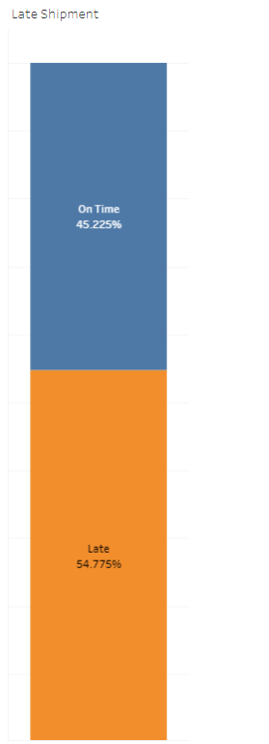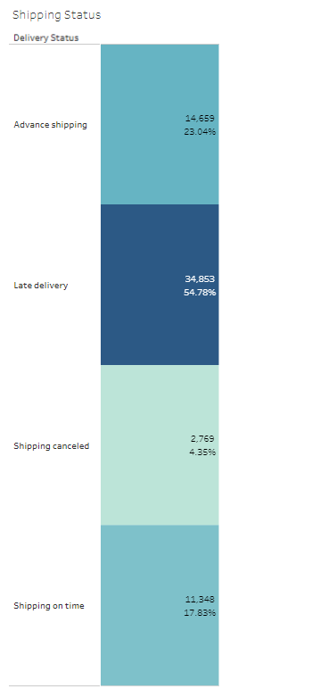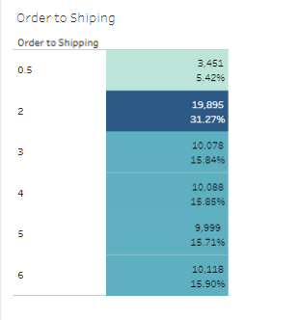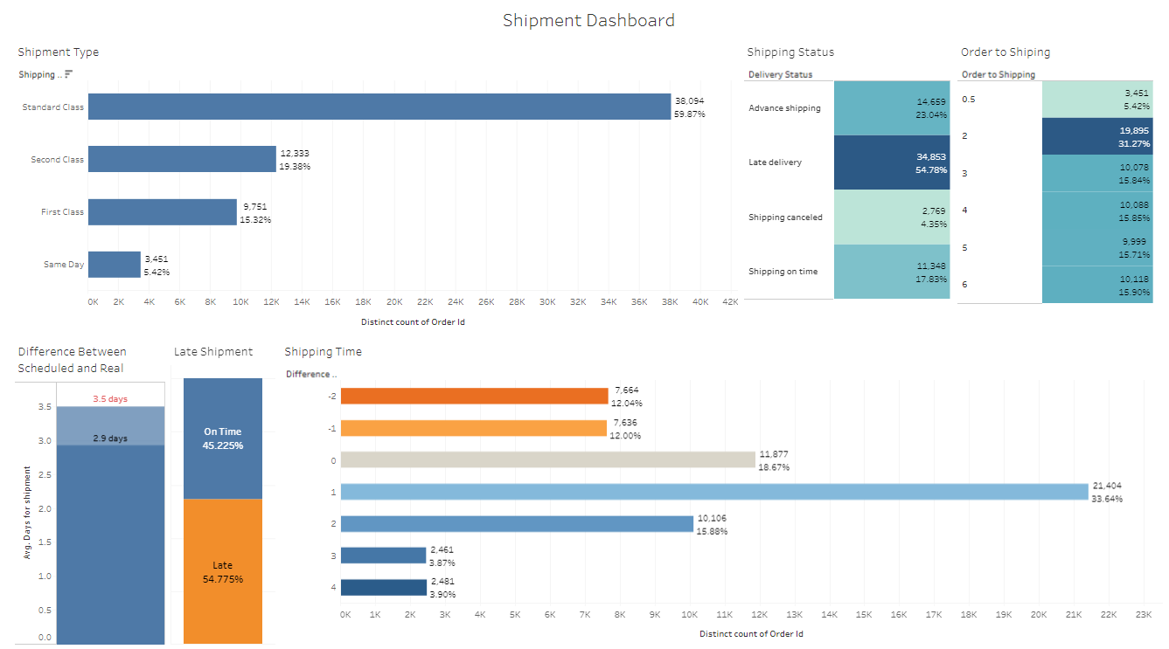

**Reference:**